**Assignment#05**

**pp 202-207 Exercises 1-46 odd**

**Exercise#1**

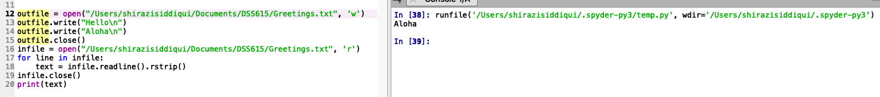

**Exercise#3**

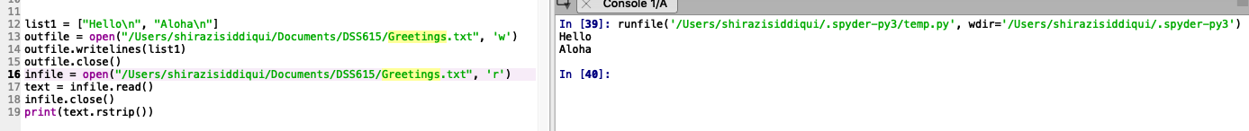

**Exercise#5**



**Exercise#7**



**Exercise#9**



**Exercise#11**



**Exercise#13**



ABC.txt should be open for reading, not for writing.

**Exercise#15**

close() should be called on the file object, infile, not on ABC.txt. The last line should read **infile.close().**

**Exercise#17**

The argument for write() must be a string, not an integer.

**Exercise#19**

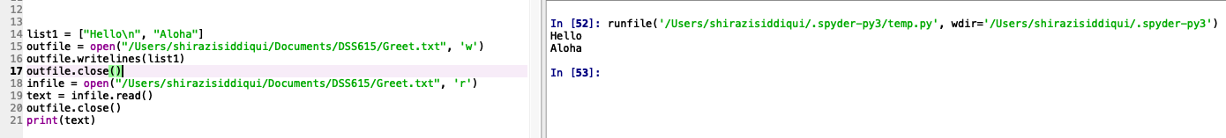

The code should close the file after writing it. Otherwise, the value of list1 will still be in the buffer and not on the disk drive when the file is opened for reading.

**Exercise#21**



The file cannot be read since it has been closed.

**Exercise#23**

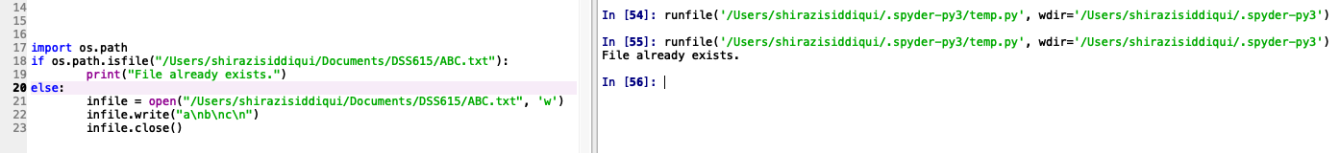

The file ABC.txt is created. Nothing is displayed on the monitor.

**Exercise#25**

**Exercise#27**

**Exercise#29**

**Exercise#31**

It displays common names from both the files:

**Exercise#33**

First four lines :

**Exercise#35**

**Exercise#37**

**Exercise#39**

**Exercise#41**

**Exercise#43**

**Exercise#45**

**pp 212-220 Exercises 1-27 odd**

**Exercise#1**



**Exercise#3**



**Exercise#5**

Each line of the new file contains the name of a European country and its population in millions. The countries are listed in descending order by population.

The first two lines of the file are :

*Russian Federation,142.5*

*Germany,81.0.*

**Exercise#7**

**Exercise#9**

**Exercise#11**

**Exercise#13**

**Exercise#15**

**Exercise#17**

**Exercise#19**

**Exercise#21**

**Exercise#23**

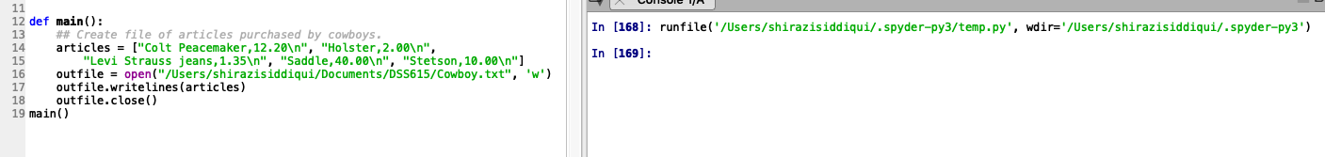

**Exercise#25**

**Exercise#27**

**pp 231-235 Exercises 1-61 odd**

**Exercise#1**



**Exercise#3**



**Exercise#5**



**Exercise#7**



**Exercise#9**



**Exercise#11**



**Exercise#13**



**Exercise#15**



**Exercise#17**



**Exercise#19**



**Exercise#21**



**Exercise#23**



**Exercise#25**



**Exercise#27**



**Exercise#29**



**Exercise#31**



**Exercise#33**



**Exercise#35**



**Exercise#37**



**Exercise#39**



**Exercise#41**



**Exercise#43**



**Exercise#45**

**Exercise#47**

**Exercise#49**

**Exercise#51**

**Exercise#53**

**Exercise#55**

**Exercise#57**

**Exercise#59**

**Exercise#61**

**pp 238-242  Programming Projects, select 5 of the projects**

﻿

**Project Program #1 : Unit Conversions**

**Project Program # 3 : Baseball**

**Project Program # 6 : Fuel Economy**

**Project Program # 7 : U.S. Cities**

**Project Program # 4 : U.S. Senate**

**a)**

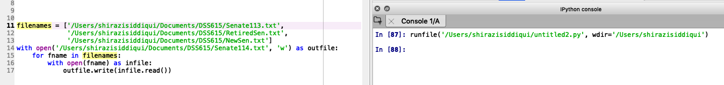

﻿ **b)**

**c)**

**d)**

